

School of Public Administration  
Bachelor of Science in Computing

**COMP492 Final Year Project  
Progress Report**Academic Year 2014/15

|  |  |
| --- | --- |
| Experiment with Lego Robot as a Indoor Helper | |
|  |  |
| Project number: | 29 |
| Student ID: | Key, Liang Yijuan  (p1107923) |
| Student Name: | [Your name] |
|  |  |
| Supervisor: | Dr. Cora Lai |
| Assessor: | Dr. CT Lam |
|  |  |
| Submission Date: | **2014/04/17** |

Declaration of Originality

I, Liang Yijuan, declare that this report and the work reported herein was composed by and originated entirely from me. This report has not been submitted in any form for another degree or diploma at any university or other institute of tertiary education. Information derived from the published and unpublished work of others has been acknowledged in the text and a list of references is given in the bibliography.

[Your signature]

[Date of signature]

Abstract

The purpose of this project is to experiment navigation approach with the Lego Mindstorms EV3 robot. Indoor positioning withRadio Frequency Identification (RFID) and landmark recognize technology is used in the project. A month was spent to analyze how other studies do navigation with the robot. Different localization approach tried in the analyzed projects will be tried to re-present in the LEGO robot which the hardware is not built up by the author of a project. Also, an android application will be developped in the project for reading the RFID tags.

In this project, the following functions will be included. Firstly, the robot could move following the landmark. Secondly, the robot could read RFID tags to get its location. Thirdly, moving path should be calculated according an algorithm. Lastly, the robot could do the delivery for some objects like markers, erasers, or lecture notes etc.

Acknowledgement

I want to express my greatest appreciation to my project supervisor Dr. Cora Lai. She spent a lot of effort to help me with my project and writing. I also want to say thank you to Prof. Giovanni Pauand Prof. Rita Tse shared the biggest support for the hardware. Without the above three people, I could not image the project would develop to the final stage.

Table of Contents

1 Introduction 5

1.1 Objectives 5

1.2 Summary 6

1.3 Risk Assessment 6

2 Background and Related Work 8

References 10

Appendix A. Project management 11

Appendix B. Program source code / UML diagram, etc 12

# Introduction

The aim of this project is to do an emulation experiment for robot navigation with Lego Mindstroms EV3. In the last two decades, a lot of experiments were done with the robots. Evidences could be found such as Azlan, N.Z [1] did a fuzzy logic control with the robot, Gijeong J. et al. did a project for indoor mobile robots with color landmark recognition. [2] Hahnel D. et al. equipped RFID with the robot for navigation. [4] This project will use Lego EV3 robot and try to replicate some of the experiments form other projects. The robot will be control be the computer through Bluetooth. Color sensor and RFID will be used for localization.

As confined by the Bluetooth signal range, the robot in this project will move in room A322 in MPI, but not move around the whole floor. In the very beginning, this EV3 robot will move on a whiteboard following color landmarks drawn with highlight pens.

## Objectives

The main task of this project is to develop and control an indoor navigation robot which can go to a desired place within a room area and do the delivery as a helper. This robot can move following the color line and fetch objects and do delivery. LEGO® MINDSTORMS® EV3 is chosen as the development model.

The following functions should be developed with the robot in this project:

* Move from starting position to different destinations
* Move according color lines
* Turn left or right correctly
* Go back to start area after reaching the destination
* Read NFC tags to recognize places
* Deliver objects to the destination

## Summary

This report is organized as follows: Chapter 1 gives some background introduction of the project. Objectives will be also listed in this chapter. Chapter 2 introduces the background of our work.

## Risk Assessment

During the process, there are four possible risks may occurs, namely battery running out, connection setup disabled, harddisk damage and data lost and motor out of function.

* Battery running-out
  + Firstly, there is a potential risk that battery runs out during the testing period. This will lead the robot move in a shorter distance as expect. Also, as movement is controlled by the motor volume, so if the battery is almost run out and cannot provide enough power for moving distance as the design. Therefore, full-charged backup batteries are prepared.
* Connection setup disabled
  + Secondly, as there are too much radio signals in the campus, Bluetooth connection may be interfered. This makes it impossible to set up the connection between the computer and the robot. If this happens, it is tested to be feasible to move to another place, for example the rooftop, to reset the connection. The connection set up process can be performed at the rooftop of the teaching building, as there is less interferes. Once the connection is set up it will not be disconnected until disconnect operation is triggered, and after connection set up, everything can be move back to the lab and resume its normal operation.
* Hard disk damage and data lost
  + Thirdly, all the develop programs or documents may lost due to hard disk problem. Therefore, besides saving data in the local computer, at least one copy backup will be placed in a USB and a backup copy will be put in the network. Once development data is lost, backup data will be used to continue the project. Furthermore, all files of the every process will have at least one backup copy so that the project can go back at any time.
* Motor out of function
  + Last but not least, In case of accident, motor of the robot may be out of function. This might stop the robot from moving. If this happen, it is necessary to replace motor with a backup that is in place.

# Background and Related Work

As the development of technology, human interactive robot development has been a big topic in the world. Developing a robot helper instead of human do by themselves has been a trend of people’s interests. Fuzzy logic design, which is introduced in 1960s, will be also used as other similar robot projects. LEGO® MINDSTORMS® EV3 programmable robot is chosen for this project because it is small enough to move and carry. Also, spare parts are available to be used to develop extra original modules as well because only a few of provided parts are used to build up the basic model this robot of LEGO® MINDSTORMS® EV3. Moreover, added sensors are also available in the LEGO® official website. And this EV3 robot also supports different kinds of connection means including Wi-Fi (but this requires an added Wi-Fi adaptor). Therefore, it is well famous to be selected in similar kinds of projects. Similar works is also done by many people. In 2007, the article Fuzzy Logic Controlled Miniature LEGO Robot for Undergraduate Training System [1] is published by IEEE. Besides, Color Landmark Based Self-Localization for Indoor Mobile Robots [2] is also publish in Korea. In this project fuzzy logic will be also designed but color recognize will simple read color landmark and Radio Frequency Identification (RFID) technology will also use for positioning.

Mobile robot with RFID sensors have been raise in the last decade. [3] Tasks like navigation, localization and mapping can be done with information inside a RFID tags. [4] Evidences can be easy found in many projects. For example, Gueaieb, W and Miah Md.S. presented an intelligent novel non-vision-based robot using RFID technology. [5] In their project, the robot was attached with two RFID antennas which was used to recognize RFID tags on the moving path for controlling the moving of the robot. In the whole process three stages of experiments was shown. All the stages were using a RFID reader attached with the robot and read tags from the moving path. In the development of the whole project, the robot was firstly tried to move following a line segment, and then tried to move following a complex path. After successfully try with the two approach and then the third experiment—moving following tags singles from the hallway is done successfully. The author considered that it is the first algorithm for tracking both a target position and a desired trajectory with an RFID system. Besides the above project, HyungSoo L et al. [3] presented an indoor robot using an efficient RFID system which a scheme for the efficient localization is designed. RFID tags with absolute position information were attached on the floor for localization in the project. Hahnel, D et al. [4] analyzed Radio Frequency Identification (RFID) could be implemented to for a better mobile robot localization.

What’s more, a mobile robot which can navigate in a known environment is developed by Hallmann and Siemiatkowska. [6] 16 sonars, 16 infrared sensors, an onboard Pentium computer, and a gray-scale camera is equipped with the robot. In this project, information on a map of the environment to be tested is built inside. The built map is developed based on information feedback from the sonar and sensors. Landmarks was also placed in specific locations to help with the navigation. This is a combination of using both RFID and landmark for a better robot localization.

References

[1] Azlan, N.Z.; Zainudin, F.; Yusuf, H.M.; Toha, S.F.; Yusoff, S.Z.S.; Osman, N.H., "Fuzzy Logic Controlled Miniature LEGO Robot for Undergraduate Training System," Industrial Electronics and Applications, 2007. ICIEA 2007. 2nd IEEE Conference on, vol., no., pp.2184, 2188, 23-25 May 2007

[2] Gijeong Jang; Sungho Lee; Inso Kweon, "Color landmark based self-localization for indoor mobile robots," Robotics and Automation, 2002. Proceedings. ICRA '02. IEEE International Conference on, vol.1, no.,

[3] Klaus Finkenzeller. RFID Handboook: Radio-Frequency Identification Fundamentals and Applications. Wiley, New York, 2000.

[4] Hahnel, D.; Burgard, W.; Fox, D.; Fishkin, K.; Philipose, M., "Mapping and localization with RFID technology," Robotics and Automation, 2004. Proceedings. ICRA '04. 2004 IEEE International Conference on , vol.1, no., pp.1015,1020 Vol.1, 26 April-1 May 2004

[5] Gueaieb, W.; Miah, Md.S., "An Intelligent Mobile Robot Navigation Technique Using RFID Technology," Instrumentation and Measurement, IEEE Transactions on , vol.57, no.9, pp.1908,1917, Sept. 2008

[6] I. Hallmann and B. Siemiatkowska, “Artificial landmark navigation system,” in Proc. Int. Symp. Intell. Robot. Syst., Jul. 2001, pp. 219–228.

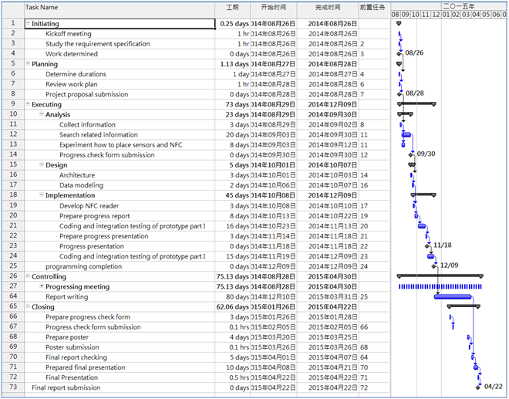Appendix A. Project management

Gantt chart, program plan

Appendix B. Program source code / UML diagram, etc

Not compulsory